
MAMC01814: User Experience Design: Design Report
ASSESSMENT 2
Study block | Block 4 2025
Due date | Monday 22nd September |  | Time | Before 11.59 PM
Delivery: | Submit to Turnitin via Moodle before deadline
Weighting | 70%
Marks out of | 100
Instructions | Complete this cover sheet and attach to you your assignment.  - This assignment must be your own work.  - Collusion, copying or plagiarism may result in disciplinary action.  - We advise that you keep a copy of this assignment.  Refer to following website for reference related resources:  http://www.cite.auckland.ac.nz/index.php?p=quickcite
Student Name | Gielo Joseph Fernandez
Student ID No | 737214696 | Cohort number |  |  |  | 1
Lecturer | Shafiq Alam | Class time |  |  |  | Mon & Wed 8:30am-12:30pm
Student declaration: | I confirm that:  This is an original assessment and is entirely my own work.  Where ideas, tables, diagrams etc. of other writers have been used, I have acknowledged the source in every case.  This assignment has not been, nor will be, submitted as assessed work for any other academic course.
Signature of student: | Gielo Joseph Fernandez |  |  |  | Date |  | August 20, 2025
A Critical Analysis of User Experience Design on AA Travel Insurance Quote Page
1. Introduction
(300 words)
In today’s age, User Experience plays a huge part in the success of organizations. User Experience, although it was first coined by cognitive scientist Don Norman in the 1990s, User Experience goes way back much farther than the 1990s (Young, 2022). User Experience (UX), often shortened for UX, is defined as the overall experience a customer or user has when interacting with a product, system, or service. UX handles all the user’s feelings about the product, including ease of use, accessibility, visual design, functions, and emotional impact (Finn & Downie, 2025). For users, UX is the whole interaction that they experienced with a product or service.
AA Insurance, a New Zealand company founded in 1994. AA Insurance has been offering insurance to New Zealanders for 30 years (Our Company and Our People - Find out More | AA Insurance, n.d.)
This report will analyse how user experience design can improve the functionality of travel insurance in AA Insurance company. Part two will discuss in detail the user experience elements, usability, accessibility, and aesthetics as they are important in achieving the goals of AA Insurance in the insurance industry. Part three will discuss the best practices of current organizations in how they implement these user experience elements. Part four will discuss Alternate design to further improve the user experience design of AA Insurance. Part 5 will end with summary and conclusion.
2. Analysis of the Current AA Travel Insurance
(600 words)
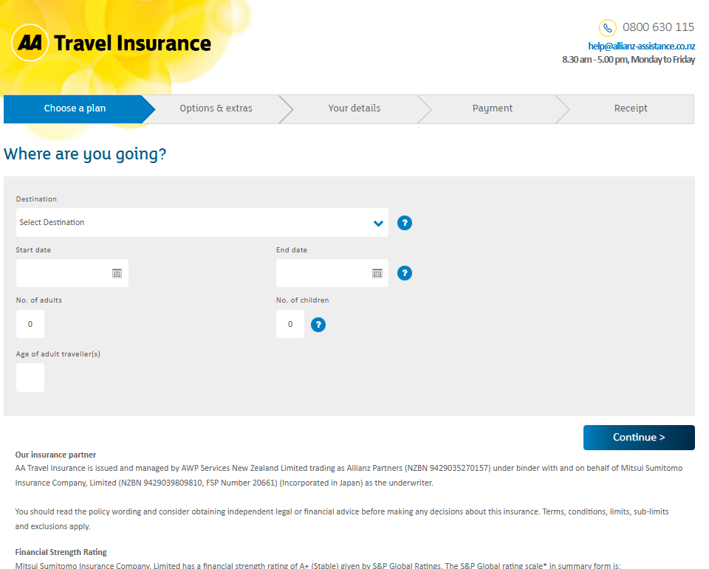
Figure 1 AA Travel Insurance Quote Page
In the figure above, the AA Travel Insurance Quote Page (AA Travel Insurance, n.d.) provides services such as domestic, and overseas travel insurance. It asks for the destination, start date, end date, number of adults, number of children, and the ages of the travellers. In case the user needs help, the page contains the email, contact number and the availability of the travel insurance agent.
The figures below will discuss in detail the components of AA Travel Insurance Quote Page.

Figure 2 AA Travel Insurance Logo
The quote page contains the logo (figure 2) of AA and the label Travel insurance. This is to help the users know that they are accessing the travel insurance and not to be confused with other insurances offered by AA.
Figure 3 Travel Insurance Steps
The quote page contains the phases/steps (figure 3), which guides the users throughout the travel insurance purchase cycle. This helps users know what phases/steps and be guided accordingly.

Figure 4 Insurance agent contact info
The quote page contains the contact number, email address, and the availability of the insurance agent. This is to inform the user if they have any questions or need assistance.
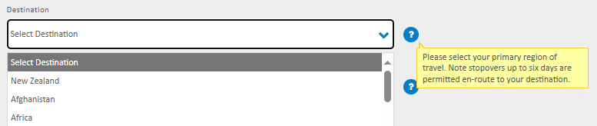
Figure 5 Select Destination
The quote page contains the select destination field, which asks the user to select the destination of their travel. In the scenario that the user is going to multiple countries, there is the tooltip that is displayed when hovered which informs the user about it.
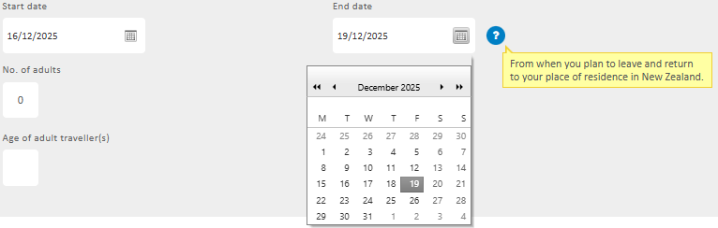
Figure 6 Select Start and End Date
The quote page contains the field where select start and end date, which asks the user to select when the start and end of their travel. It is in calendar format to help to easily identify the dates. There is added tooltip to inform the user more information about the dates.
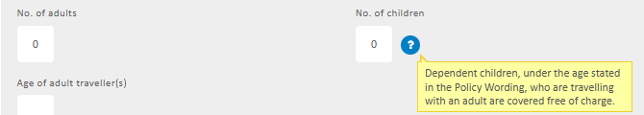
Figure 7 Enter No. of adults and children
The quote page contains the fields to enter the number of adults and children. This is to indicate how many adults and children will be covered in this travel insurance policy. There is added tooltip to inform the user more information about the children.
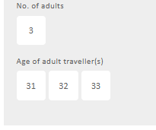
Figure 8 Age of adult traveller(s) Field
The quote page contains the field to enter the ages of the adult travellers that will be covered in this policy. The number of fields depends on the number of adults (ex. 3 adults – 3 fields).

Figure 9 AA Travel Insurance Continue Button
The quote page contains the ‘Continue’ button. After the user enters the destination, start date, end date, number of adults & children, and the age of adults. The continue button proceeds to the next step which is the selection of plan.
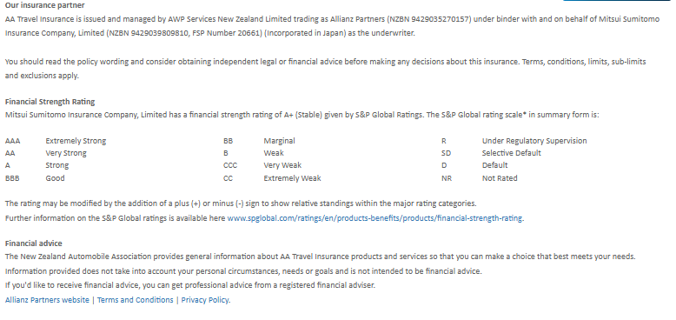
Figure 10 AA Travel Insurance Footer
Finally, the quote page contains the footer, which contains the insurance partner details, financial strength rating, financial advice disclaimer, and other information (partner websites, terms and conditions, privacy policies).
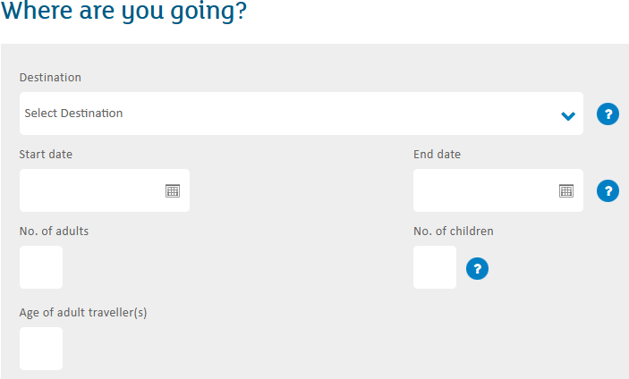
Figure 11 Entering User Info
In terms of usability, the AA Travel Insurance quote page uses simple labels such as ‘Destination’, ‘Start date’, ‘End date’, ‘No. of adults’, ‘No. of children’, and ‘Age of adult travellers’. This is to make sure users are familiar with it even for first time users, as these users spend most of their time on other sites, users expect AA Travel Insurance to function like all the other sites they already know (Nielsen, 2023).
However, there is lacking in the purpose of the traveller, the traveller may have different purposes such as travel, work, and study.
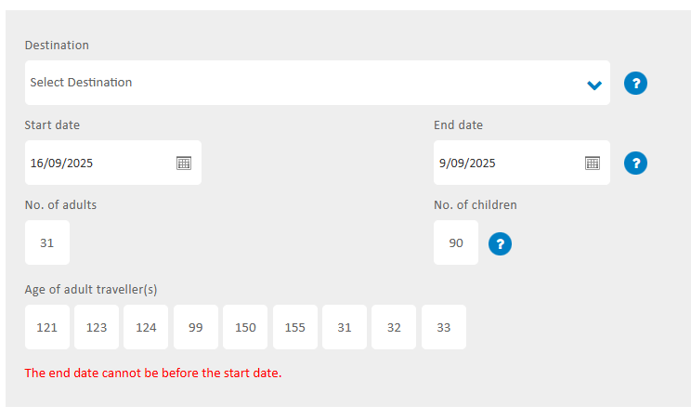
Figure 12 Error Checking
In terms of error checking, while it has the correct error checking message, it can be misleading because the error is located at the bottom of the page, far away from the actual error. This is bad as the error message is best placed near the actual error (Error-Message Guidelines, n.d.).
The absence of chatbot functionality is bad as while the page has the hotline and email address available, it is much more hassle as you need to contact them. When users can easily find the information they need or resolve their issues quickly, they are more likely to be satisfied with their interaction with the chatbot and the business as a whole (Narasimhan, 2025).
3. Evaluation of User Experience Design of AA Insurance Travel Insurance Page
(900 words)
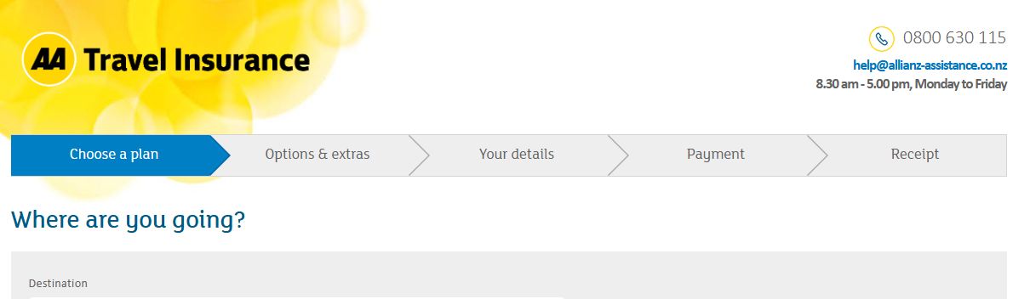
Figure 13 AA Travel Insurance Header
The header (Figure 13) in AA Travel Insurance Quote Page clearly indicates that the user is in the travel insurance page. This is good as it follows the Jakob Nielsen’s ‘Visibility of System Status’, which states that when users know the current system status, they learn the outcome of their prior interactions and determine next steps (Nielsen, 2024). Although, if we compare the headers of other AA insurance products (figure 14 below).

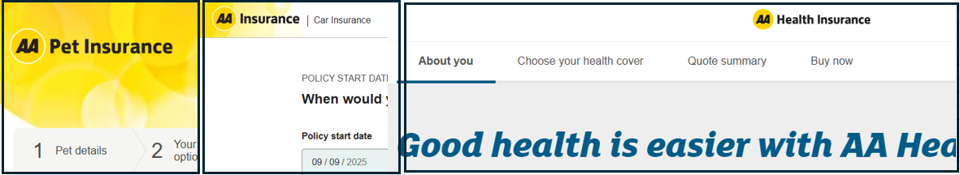
Figure 14 Headers of Pet, Car, and Health Insurance
We see that while the header is similar to pet insurance (AA Pet Insurance | You and Your Pet, n.d.), the header of car insurance (AA | Car Insurance, n.d.) and health insurance (AA | Health Insurance, n.d.) looks a bit different. This is bad as there is no internal consistency between AA insurance products, which is under Jakob Nielsen’s ‘Consistency and Standards’, which states we should maintain consistency within a single product or a family of products (internal consistency) (Nielsen, 2024).
Figure 15 Travel Insurance Steps
The steps as shown in figure 15 in AA Travel Insurance Quote Page is used to guide the user throughout the purchase of travel insurance policy. This is good as it complies with Jakob Nielsen’s ‘Visibility of System Status’, which mentions that to prevent confusion and frustration, it is best to inform them where they are in the process, and in this case the display of progress and loading bars (Nielsen, 2024).
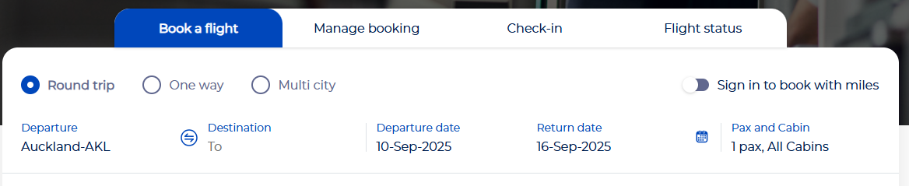
Figure 16 Philippine Airline Booking Page Progress Bar
There are many similar implementation of the progress in other industries, one in which is the figure 16, which shows the progress bar in Philippine Airline Booking Page (Book a Flight, n.d.), mainly used to act as progress bar and guide for the user who wants to book a flight.
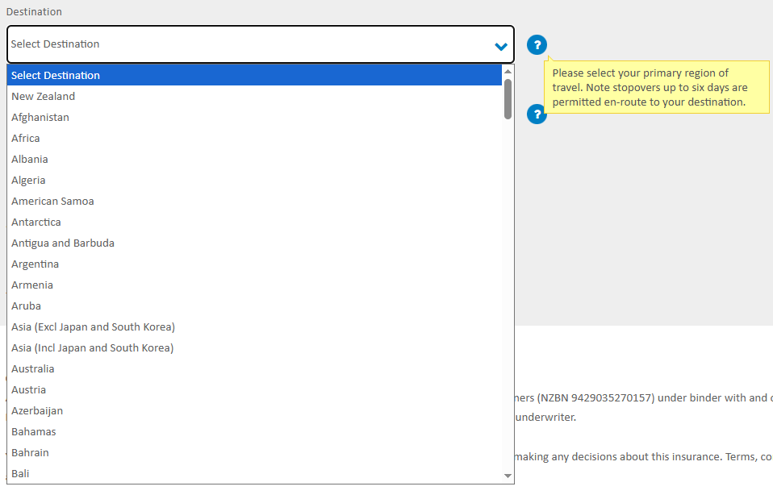
Figure 17 Select Destination Drop Down Menu
The tooltip in figure 17 adds information regarding the destination field. The information is more focused on travellers that are going to multiple destinations. This is good because a tooltip's main purpose is to offer helpful, additional information, aiding users in completing specific tasks (Helin & Eklund, 2023).
Regarding the select destination field in figure 17, AA insurance currently uses a drop-down menu. This is bad as there is quite a really long list of all the countries. If the destination is in the most bottom, you have to scroll all the way down. This violates Fitt’s law where the the farther the distance to the target (ex. destination), the longer it will take for the pointer to move to it (Budiu, 2022). Southern Cross Travel Insurance (Southern Cross Travel Insurance - Compare, Quote, Buy Online | SCTI NZ, n.d.) has a different approach. The figure 18 below shows the Southern Cross Travel Insurance.
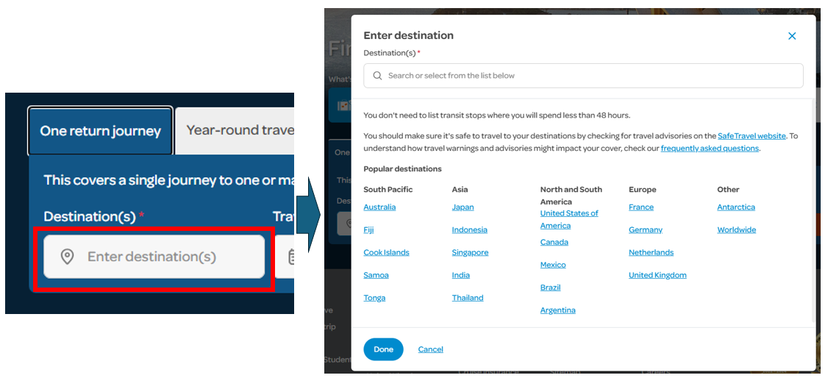
Figure 18 Southern Cross Travel Insurance - Destination Field
In figure 18, after clicking the destination field, a pop-up window appears where the user can either select from the popular destinations or type in the destination in the text field. This is better because it is quicker to select the popular destinations or type in the destination than selecting from a very long list of destinations. There are different approaches designing destination fields in other industries, such as aviation. Figure 19 below shows the destination field in Air New Zealand (Air New Zealand – Book Flights & Earn AirpointsTM, n.d.).
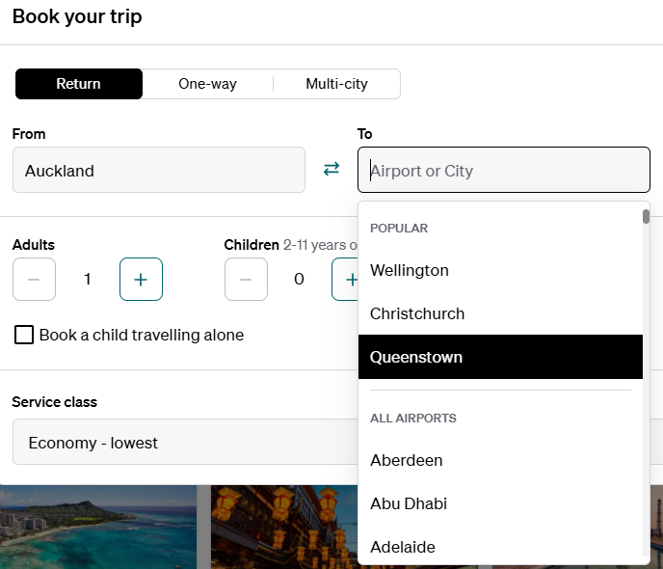
Figure 19 Air New Zealand Destination Field
The Air New Zealand’s (Air New Zealand – Book Flights & Earn AirpointsTM, n.d.) destination field in figure 19 uses a search bar with the popular destinations as the top choices. As the user, the quickest way to fill up the field is to either select from the popular choices or type in the first few characters and select the destination. This is good as this is quicker than the way AA insurance implemented it.
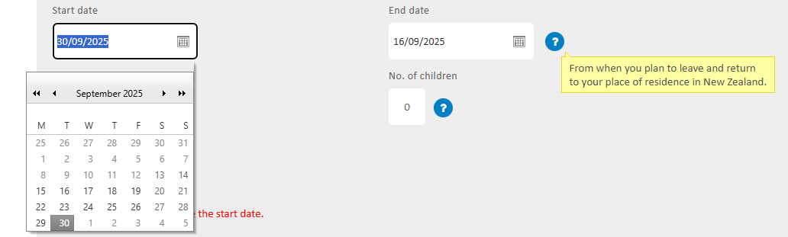
Figure 20 AA Travel Insurance - Start & End date field
In figure 20, AA Travel Insurance uses date picker to easily select date. This is okay as it is better than the text field. On mobile devices, where screen space is limited and touch interaction is primary, a date-picker can be more intuitive and accurate than a text field, which may require zooming functions for clear input. However, there are ways to improve it. If we compare it at Allianz Travel Insurance (Allianz Travel Insurance, n.d.), which is shown in figure 21 below.
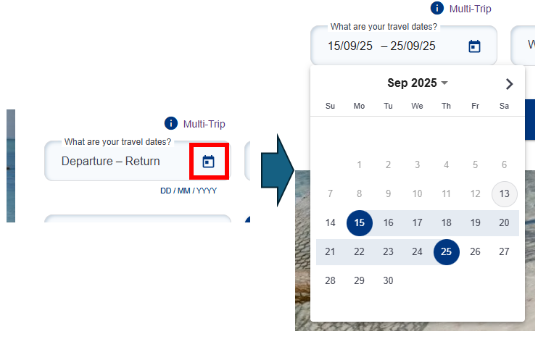
Figure 21 Allianz Travel Insurance Date field
The date picker used by Allianz (Allianz Travel Insurance, n.d.) is much more compact and effective than AA insurance, the user can select the start and end date in the same date picker. It also requires less clicks or actions than AA insurance. This is the goal as designing user interfaces (UIs) to require fewer clicks or actions is a fundamental goal aimed at enhancing user experience, particularly through improving efficiency, reducing cognitive load, and minimizing user errors (Hui & See, 2015). Air New Zealand (Air New Zealand – Book Flights & Earn AirpointsTM, n.d.) implements a similar approach, as shown in the figure 22 below.
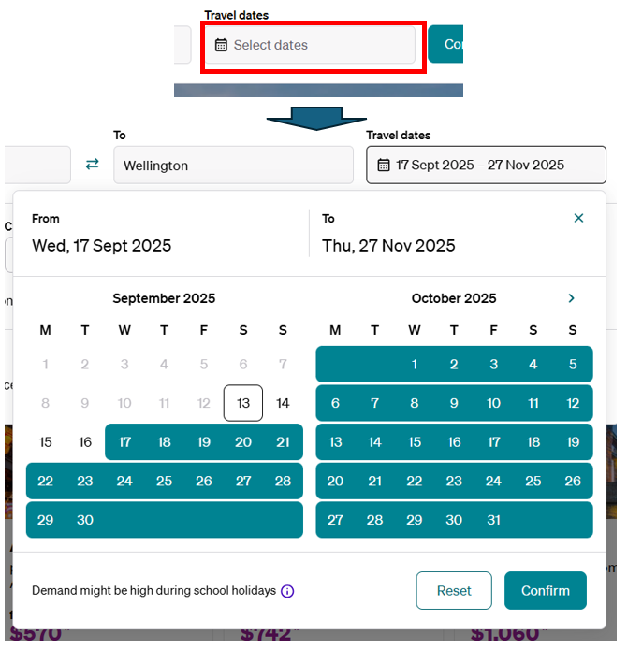
Figure 22 Air New Zealand Select Date Field
The date picker in figure 22 is uses 2 date window to view both the start and end date. The use of animation of filled out colour as visual cues to identify the date range is good for visual appeal. Visuals can compact information, transforming complex data into understandable insights quickly. Aesthetically pleasing and visually engaging interfaces contribute to user satisfaction and can even enhance perceived usability, a concept known as "apparent usability" (Blair-Early & Zender, 2008).



When compared with other AA insurance products, you can see a bit of semblance of the design.
The logo in AA Travel Insurance Quote Page clearly shows the stages of buying a travel insurance policy(Choose a plan, Option & Extras, Your Details, Payment, Receipt)
Lorem ipsum Dolor Sit Amet\
First paragraph - This part is comparative which means( compare the current UX in terms of the component you choose such as usability against usability principles(research on it))

Second Paragraph - What are the areas of improvement for example whatever is missing or not good in terms of best practices (current trends)

3rd Paragraph - What are the areas of improvement for example whatever is missing or not good in terms of best practices (future developments)

(to write these section keep in mind to focus on the ux not the organization)

• Based on your analysis in step 1, evaluate how the organisation's user experience design aligns with best practices in user-centred interaction design. Identify any areas where the organisation's user experience design falls short and needs improvement according to user-centred design principles.
Evaluation - In the evaluation,
ANZ has a mobile app that provides a chat function - description / not evaluation

ANZ has a chat function which does not properly work - analyzing

ANZ has a mobile app that is very limited - analyzing

is compared to in terms of
1. has these issues in compared to usability principles/user experience/best principles

2. and compared to these/other organization
compare to other good organization

3. compare function to function(other industry)

compare side by side and compare it

Air NZ has one of the best designs that it is following
certain principles, but it is not following this principle

Addressing cultural biases
improve user experience by including of local tradition and norms and that it well used

avoiding any bias or stereotypes

ANZ should be aking care on

motibvations - eternal api
what is explainability

transparency and fairness

explainability is the key to the foundation of AI
4. Design of the recommended AA Insurance Travel Insurance Page
(900 words)
Based on the evaluation done on AA Travel Insurance page, some alternative designs are recommended to improve user experience.
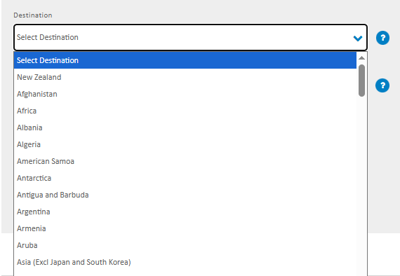
Figure 23 AA Travel Insurance Destination Field
Currently, AA travel insurance uses a drop down menu in the destination as shown in figure 23 above. A better alternative is to add a search field and the drop down menu contains the popular destinations and the list of countries. The figure 24 below shows how it could be implemented.
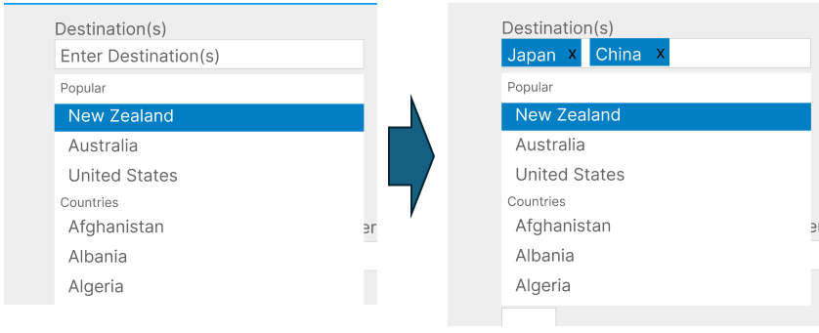

(feel free to put images from the existing apps and comparative apps, etc and point to them)
Lorem ipsum Dolor Sit Amet
Design
-Make the design
-Connect evaluation
-AS a design fix in the issue it is in the design section

these are the good things
these are the bad things

-How important is AI in contemporary

discuss positive and negative effects of AI
If it is using AI, what should the organization be careful about

The problems I have identified , can be solved with AI solutions, however. AI has issues with ...

Then discuss the designs created
5. Conclusion
(300 words)
Lorem ipsum Dolor Sit Amet
6. References
AA | Car Insurance. (n.d.). Retrieved September 10, 2025, from https://go.aainsurance.co.nz/motor/quote.html#policystartdate
AA | Health Insurance. (n.d.). Retrieved September 10, 2025, from https://health.aa.co.nz/about-you
AA Pet Insurance | You and your pet. (n.d.). Retrieved September 10, 2025, from https://sales.aapetinsurance.co.nz/
AA Travel Insurance. (n.d.). Retrieved September 8, 2025, from https://travelinsurance.aa.co.nz/processing/ChooseAPlan.aspx
Air New Zealand – Book Flights & Earn AirpointsTM. (n.d.). Retrieved September 13, 2025, from https://www.airnewzealand.co.nz/
Allianz Travel Insurance. (n.d.). Retrieved September 13, 2025, from https://buy.allianztravel.co.nz/get-travel-insurance
Blair-Early, A., & Zender, M. (2008). User Interface Design Principles for Interaction Design. Design Issues, 24(3), 85–107.
Book a flight. (n.d.). Phillipine Airlines. Retrieved September 10, 2025, from https://www.philippineairlines.com/nz/en/home.html
Budiu, R. (2022, July 31). Fitts’s Law and Its Applications in UX. Nielsen Norman Group. https://www.nngroup.com/articles/fitts-law/
Error-Message Guidelines. (n.d.). Nielsen Norman Group. Retrieved September 9, 2025, from https://www.nngroup.com/articles/error-message-guidelines/
Finn, T., & Downie, A. (2025, January 10). What is user experience (UX)? https://www.ibm.com/think/topics/user-experience
Helin, S., & Eklund, A. (2023). Evaluating the use of Brush and Tooltip for Time Series visualizations: A comparative study.
Hui, S. L. T., & See, S. L. (2015). Enhancing user experience through customisation of UI design. Procedia Manufacturing, 3, 1932–1937.
Narasimhan, L. (2025, January 8). Chatbot UX: Boosting User Engagement and Satisfaction for Your Business. https://www.thealien.design/insights/chatbot-ux, https://www.thealien.design/insights/chatbot-ux
Nielsen, J. (2023, September 8). Jakob’s Law of the Internet User Experience. UX Tigers. https://www.uxtigers.com/post/jakobs-law
Nielsen, J. (2024, January 30). 10 Usability Heuristics for User Interface Design. Nielsen Norman Group. https://www.nngroup.com/articles/ten-usability-heuristics/
Our company and our people—Find out more | AA Insurance. (n.d.). Retrieved August 21, 2025, from https://www.aainsurance.co.nz/about-us/about-our-company
Southern Cross Travel Insurance—Compare, Quote, Buy Online | SCTI NZ. (n.d.). Retrieved September 13, 2025, from https://insure.scti.co.nz/
Young, N. (2022, March 30). The Past, Present and Future of User Experience (UX) Design. https://extendedstudies.ucsd.edu/news-events/extended-studies-blog/the-past-present-and-future-of-user-experience-(ux)-design

